Steps to update Jenkins.

1. Goto to Jenkins URL

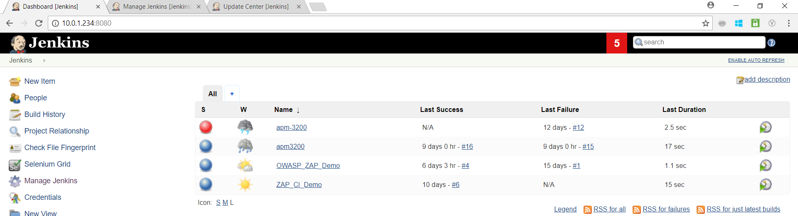

1. Click on Manage Jenkins

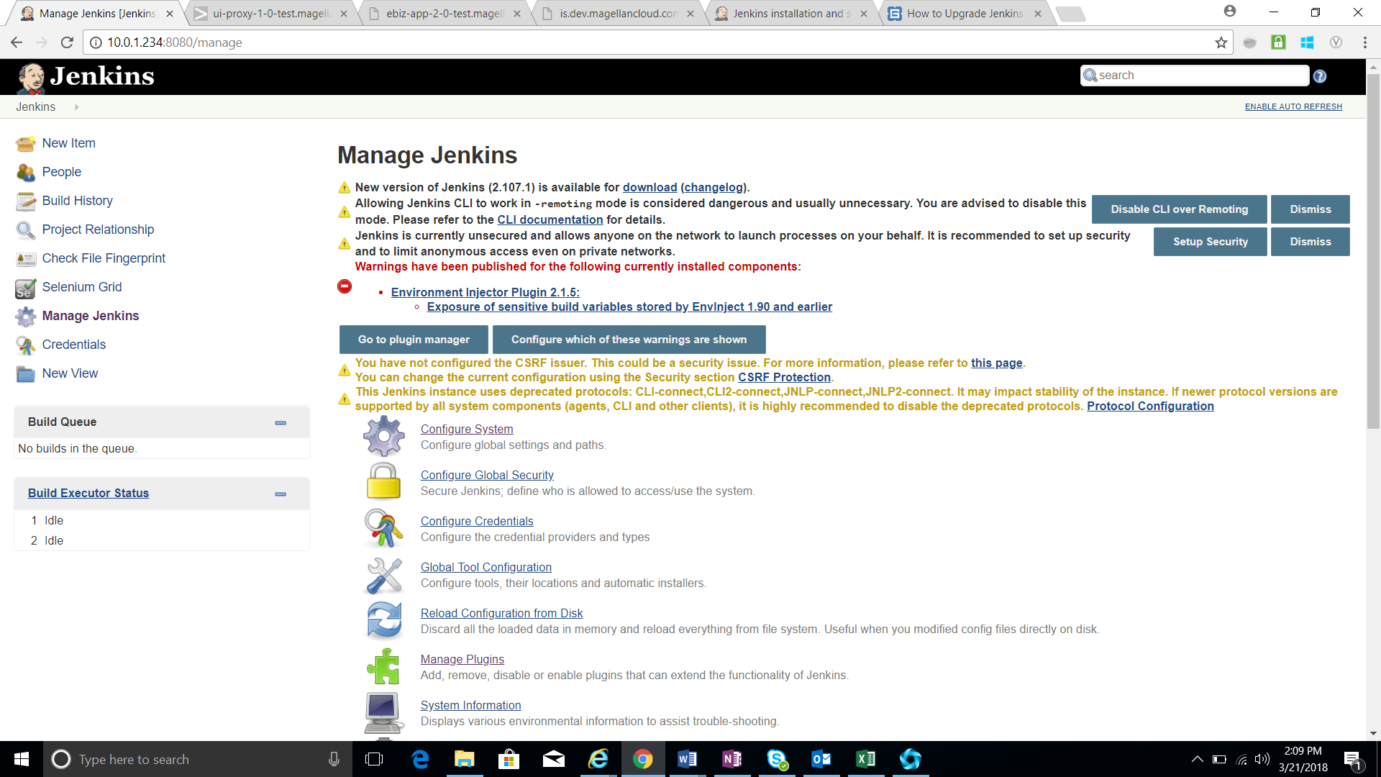

1. Check whether the new version of Jenkins is shown and also click the download link and download the new WAR file.



1. Login to Jenkins instance using putty and follow the steps in the below Screen for updating the Jenkins version

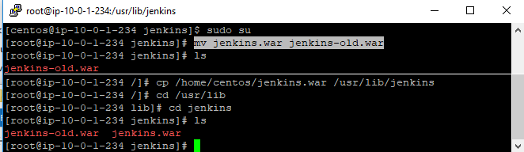

1. Restart the Jenkins server and the Jenkins version gets updated .

